Curriculum Vitae

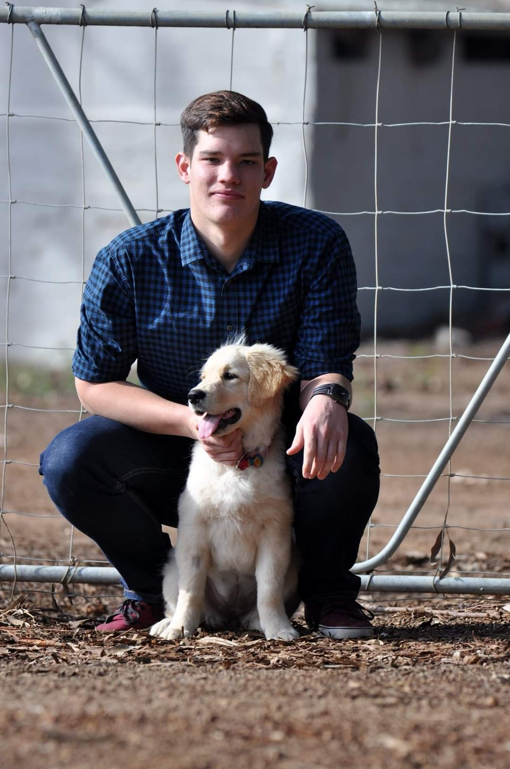Luhan Malan

16 Ribbok Crescent

Uitzicht

Durbanville

7550

Personal Information

My name is Luhan Malan born and raised in Durbanville, Cape Town. I like to go fishing, camping, and spending time at home with my family, friends, and animals. I play video games and like to repair and build PC’s in my spare time.

Name: Luhan Marcel

Surname: Malan

ID number: 011123 5116 089

Contact number: **073 6565 135**

Email address: [luhanmalan4@gmail.com](mailto:luhanmalan4@gmail.com)

Address: 16 Ribbok Crescent

Uitzicht

Durbanville

Language: Afrikaans; English

Marital Status: Single

License: Code 08

Qualifications

* Matriculated in 2019 at Durbanville High School.

Subjects: Afrikaans

English

Mathematics

Life Orientation

Science

Biology

Geography

* Member of The Voortrekkers for 12 years.

Achieved the Presidents Verkenner award in 2019.

* BSc IT Software Engineering January 2020 – December 2022

Studied at Eduvos Durbanville (formerly Pearsons). My main coding language is C#.

Other - HTML, CSS, SQL.

Kindly see academic transcript attached for more information.

Please also find attached a compressed file containing applications that I have made thus far.